4M Starch Yankee Glue Test Plan
Mehoopany, 4M paper machine
Start Date: 12 Nov 01
End Date: 26 Nov 01

Objective
- Reapply starch (Redibond) glue package to 4M from 2/5/6M for cost savings (150M/year)
- Maintain or improve 4M reliability as related to Yankee glue impacts
- Evaluate capability of 4M to run starch based Yankee glue

Background
The starch Yankee glue package has been successful in replacing the three component glue package on 5/6M. Starch glue is less expensive (150M/year savings for 4M) and has given increased sheet control for 2/5/6M.

Success Criteria
- No safety or environmental incidents occur as a result of this test.
- It is determined if 4M can move to using a starch based Yankee glue
- No negative reliability impacts due to starch glue
- No negative impact to converting reliability due to starch glue
- No negative impact to finished product quality due to starch glue

Readiness Criteria
- Machine is operating at centerlines and is stable at start of test
- PPA is completed and reviewed by teams and project resources
- Starch temporary delivery system is in place and functioning
- All necessary resources available and team staffing frozen
- HOLD stickers are available for test
- Test plan reviewed with Stock Prep and Converting
- Test plan and NOT are reviewed and signed by all supporting MEH resources

PREWORK
- Formulate reel and FP sampling plans. Submit test support request with FP lab.
- Receive Production Planning and converting input.
- Obtain Stock Prep support for delivery
- Complete MEH cost estimate
- Complete MEH NOT and obtain all necessary signatures
- Install temporary delivery system and PSI
- Complete IRRT approval

Abort Criteria
Abort only after consulting with test support contact or if immediate safety/environmental issue.
- Any irresolvable safety and/or environmental issue.
- Any irresolvable customer or supplier issue.
- Tons lost jeopardizes production schedule commitment
- Product quality within formula card specifications is unachievable.
- Number of sheetbreaks is averaging >20 per day for 3 consecutive days.
- Number of cleaners changed is averaging >30 per day for 3 consecutive days.
- Number of creepers changed is greater than 15 per day.
- No progress towards test objective.

Safety
- Mehoopany site and PMKG safe practices are followed.
- Appropriate JSA’s and MSDS’s are reviewed by teams and resources prior to the test.
- Safety issues are discussed at all meetings associated with test execution.
- IRRT guidelines and process will be followed.
- Safety walk-throughs and BOS audits are conducted during the test.
- Off-site personnel are properly instructed with regards to safety.
- Unresolved and immediate safety concerns are reported to Ken Walker (x3791).

Cost & Risks
- Cost of starch (Redibond) for test. Should end up a savings versus 3CG.
- Delivery system parts. Mainly tubing and fittings required.
- Risk of pickout holes. Decrease add on or decrease starch component to correct.
- Risk of glue in the sheet. Primary risk is during transition from old to new glue.
- Risk of poor dry transfer. Indicators would be popcorning out of pressure roll nip and poor upper press hygiene. Based on increased tack on other machines risk is low.

Test Strategy/Schedule
- Turn on starch pump at 1.8 #/ton, 80/20 ratio addition rate
- At same time, set PVA flow in gpm for 1.8 #/ton, 80/20 ratio
- At same time, turn off crepetrol and rezosol delivery systems
- Hold first 6 turnovers until reel quality confirmed. Test each one and release as that turnover is verified ok.
- Web inspect every turnover for holes/glue in sheet until continuous release (blank forms in glue test binder in control panel)
- Perform bi-hourly machine inspections and record on forms (blank forms in the binder)

Data CollectioN
Data collection forms are required for the bi-hourly machine tours (superscript 1 in table) and the turnover web inspections (superscript 2 in table). Copies of forms are attached to test plan and available in the 4M Starch Yankee Glue binder in the control panel. Completed forms placed in the appropriate section of the binder.

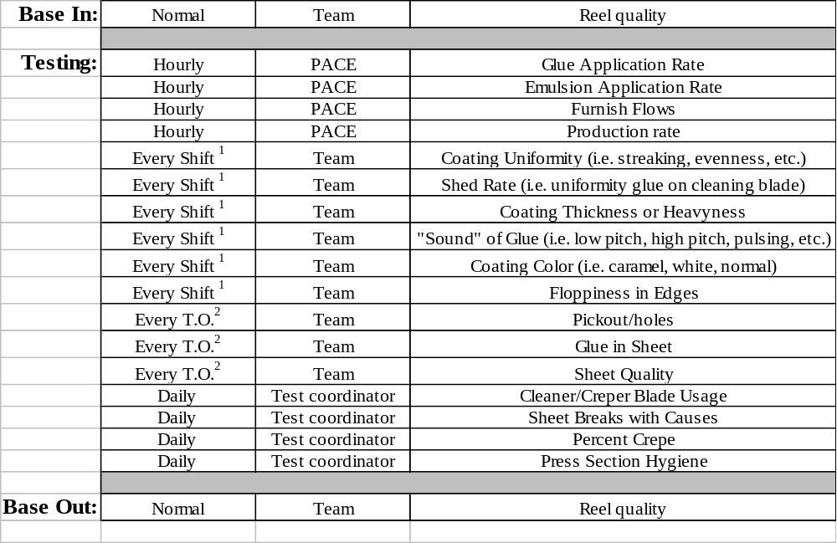
First 6 turnovers will be held in the machine room until normal reel quality checks completed. Release each turnover once quality check complete.

Communication
- There will not be a pre-test meeting unless requested.
- The test plan will be reviewed with the teams and placed in the 4M Starch Yankee Glue binder in the control panel.
- There will be a daily status report until continuous release is achieved.
- There will be a test wrap up email and final report (posted to NOT)

Staffing
<normally a table with a list of roles, who fills the role, and their contact info>
<except for groups like the teams or the lab this is your test support team>
Role | Resource | Contact Information
Test Coordinator | James Watkins (Dr. J) | x6516, 836-6530, 480-2407
Technical Resource | Ed Aprahamian | *634-3228
Technical Resource
Machine Sponsor | Ed McGinley | x3105
Quality Resource | Kai Chan | x6116
Converting Contact | ? | ?
MEG Contact | Laurie Cecere | x3285
Stock Prep. Contact | Ken Hegedty | x6446
Operating Team | 4M teams | x3297
Quality Lab | Richard Jesse | x3438

Product Disposition Plan
Brand Codes/Package Standards:
No new brand codes or package standards required.

Holds:
No finished product will be put on hold. Lot release will occur from the reel. Every turnover will be inspected for holes and glue in the sheet until continuous release. Information from the web inspections will be recorded on the turnover data collection sheets (blank forms in the 4M Starch Yankee Glue binder in the panel). Hold or reject turnovers as necessary.

FP sampling will require 250 holes and specks tests for qualification. Continuous release after 5 days of no unacceptable holes or glue in the sheet at the reel (decision made by Kai Chan).

PPA
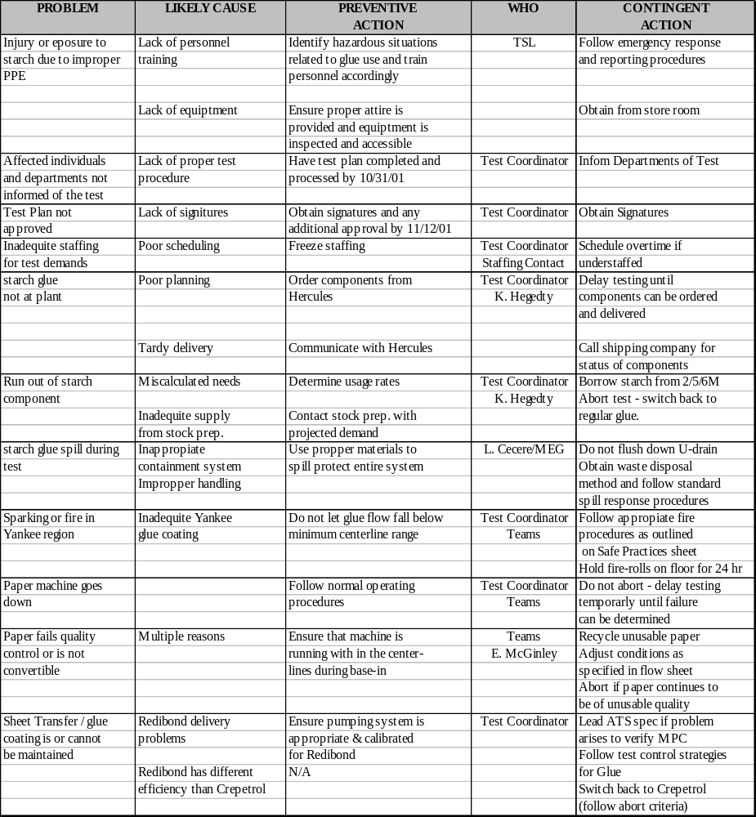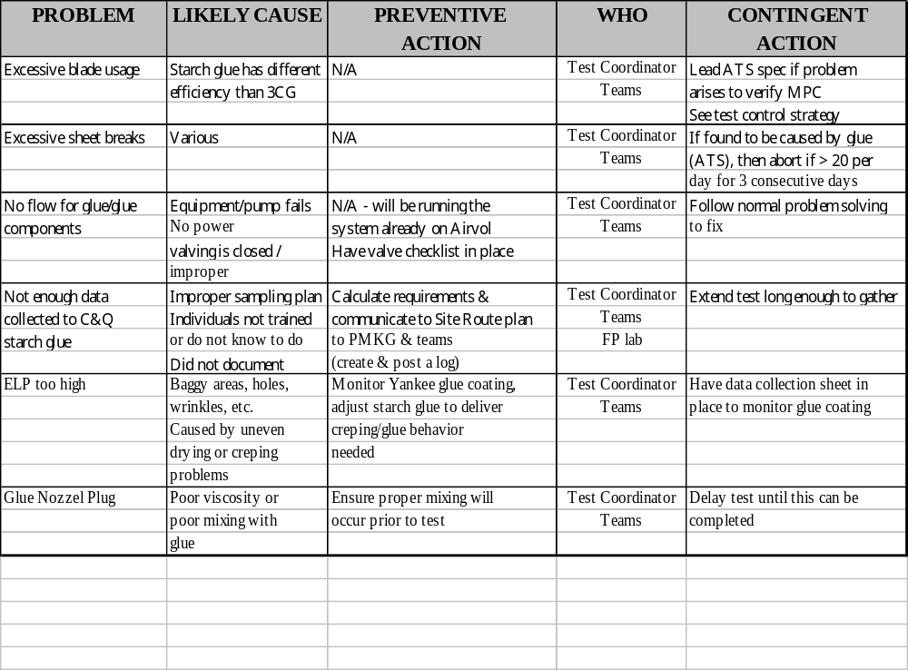

Attachments
- Turnover data collection forms (completed by teams on every turnover until continuous release)
- Bi-hourly machine surveys (completed by teams every two hours)
- Daily data collection form (completed by test coordinator for use with daily updates)
